SPORTZ 3

SPORT BONE CONDUCTION HEADPHONES

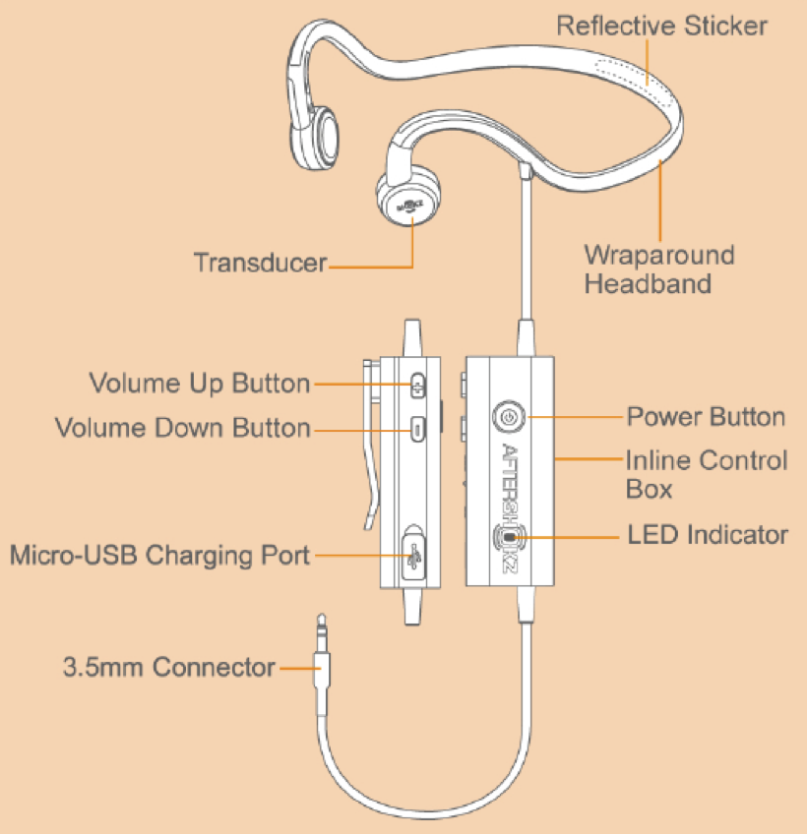

Parts descriptions
- Transducers: Two soft pads, each about the size of a thumbnail, that rest on the cheekbones. The Transducers are housed on both ends of the headphones.

- Wraparound Headband: The Wraparound Headband is the plastic headband that loops around the base of the head when wearing the device.

- Reflective Sticker: A single 3 centimeter long silver Reflective Sticker is located on the outside of the Wraparound Headband. The Reflective Sticker is intended to improve visibility in dark conditions.

- Inline Control Box: A rectangular box located partway down the 45 centimeter headphone cable, connected to the headphones. The Inline Control Box includes three buttons to control the headphones.

- Cable Clip: A small clip located on the back of Inline Control Box to secure the cable to clothing during exercise.

- Power Button: A round raised button located in the front side of Inline Control Box. Click once to turn on or turn off.

- Volume Up/Down Button: The Volume Controls are two small buttons, located on the side of Inline Control Box. There is a raised dot on the Volume Up Button, and the button below is the Volume Down Button.

- Micro-USB Charging Port: The Micro-USB Charging Port is located on the lower right side of the Inline Control Box and covered by a small flexible protective cover. The cover can be opened using a fingernail and is hinged at the back. When opened, the Micro-USB charging port is revealed.

- LED Indicator: A small light located on the lower front side of Inline Control Box that indicates charging status visually. When fully charged, the LED Indicator will appear blue, and when the device is being charged, the LED Indicator will appear red.

- 3.5mm Connector: Small plug to insert into headphone jack on the electronic device or mobile device.

Accessories

Micro-USB Charging Cable

Zippered Storage Pouch

Instruction Manual

Warranty Registration Card

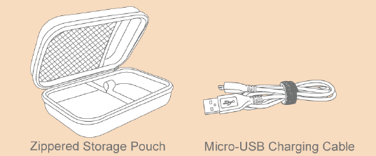

What’s special?
- Sportz 3 are stereo sport headphones that rely on bone conduction technology to transmit sound.
- The patent-pending OpenFit™ design promises ambient sound awareness and extended comfort that is unmatched with traditional headphones.
- PremiumPitch™ is our patent-pending technology that provides the finest and most detailed audio.
- A nanotechnology coating and watertight rubber gaskets repel sweat and moisture from the inside out.

How to wear
- Begin by holding the headphones horizontally, with the transducer side facing up, closest to your body. Lift the headphones over your head, so the back of the wraparound headband sets in place at the base of your head and the Transducers rest on your cheekbones in front of your ears (not nested inside or covering your ears).
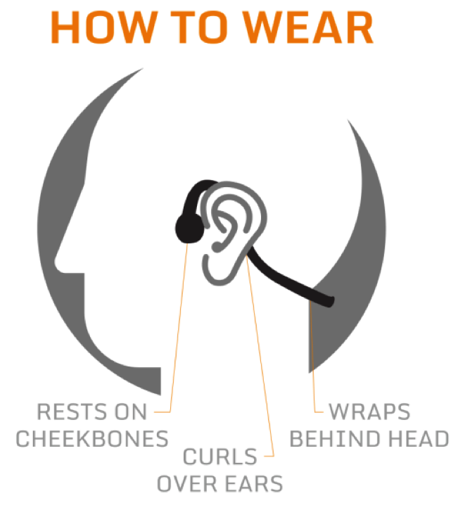

How to operate Sportz 3
- To turn on/off
Click the Power Button to turn on/off headphones. The LED Indicator will flash a blue light every four seconds when the headphones are on.

Note: If the power is on and there is no signal input for 15 minutes, the headphones will automatically enter Standby Mode to save power. The LED Indicator will flash twice with a blue light every 10 seconds.

Once in Standby Mode, there will be a two second delay before playing music or making phone calls while the headphones “wake up”.
When the battery is low, the LED Indicator will flash a red light every four seconds.
- Charging:
Connect Sportz 3 to a standard USB port on your PC or a wall charger with the Micro-USB Charging Cable. Sportz 3 will be fully charged within two hours. The LED Indicator will display a solid red light when charging, and will turn solid blue when it’s fully charged.

Note: Though the headphones may have power right out of the box, it’s recommended that Sportz 3 be fully charged before their first use.

The battery is designed to last the life of the product. It should only be removed by a recycling facility. Any attempt to remove or replace your battery may damage the product and void the warranty.

- Volume Control:
Use the Volume Up and Volume Down Buttons to increase or decrease the volume.
- Reflective Sticker:
For maximum visibility in darkness, make sure the Reflective Sticker is not covered by hair or clothing.

Specifications
Transducer type: bone conduction transducers
Transducer sensitivity: 100 ± 3dB
Frequency response: 20Hz – 20KHz
Rechargeable lithium battery
Playback time is up to 12 hours
Charging time is 2 hours
Cable length: 51 inches/130 centimeters
Weight: 1.6 ounces/45 grams

Storage and maintenance
- Store the headphones in cool and dry place. The working temperature should be 0~45℃(32~113ºF). Working in a cold/hot environment or highly humid area will reduce the life of battery.
- If stored for a long period of time, recharge the headphones before using again.
- The headphones are sweat resistant, but are NOT waterproof. Please DO NOT submerse the headphones in water.
- Listening to headphones at a high volume may affect your hearing and the audio will be distorted.
- Clean the headphones with a soft dry cloth.
- Do not charge the headphones right after exercising, in case there’s sweat inside the charging port. This could lead to the circuit burning while charging. Keep the charging port dry before connecting to the charger to reduce this risk.
Note: Design and specifications are subject to change without notice. For the most up-to-date product information, please visit aftershokz.com.

How to contact us
AfterShokz
6311 Fly Road
Suite 106
East Syracuse, NY 13057
sales@aftershokz.com
aftershokz.com

Note: If you need to return your product for repair, replacement or warranty service, please contact the AfterShokz Customer Support Center at: 1-315-218-0308 (United States).

